2025-2026 ARDP Progress Report
April 1, 2025, to December 31, 2025

Project Name: Integrating Alternative Weed Control Methods in Commercial Orchards
Project OSP#: 182161
PIs: Michael Basedow and Anna Wallis

Objective 1: Evaluate the efficacy of replacing contact herbicide materials with mechanical weeding implements within an integrated weed management program.

Task 1.1: Establish two on-farm research trials with a commercial orchard in the Champlain Valley. Each trial will consist of two treatments. 1) The grower’s standard seasonal weed management program of their choosing and 2) An adjusted weed management program where contact materials are replaced with mechanical weeding implements. Implements may vary between trials, depending on the age of the block, soil type, etc. Mechanical weeding will be used when weeds reach 30% ground cover or are 8 inches in height, whichever comes first.

Progress: In 2025, we successfully applied our treatments to two blocks at Chazy Orchards in the Champlain Valley to compare the grower’s standard program to a modified weed management program that incorporates a Rinieri SRL mechanical weeding unit. We mechanically weeded both field sites on May 14 and June 12. The grower standard plot received an application of Gramoxone at 2.2 Pt/acre on May 15. Both treatments also received a spring pre-emergent treatment of 1 Qt/A Prowl H2O on May 14 and follow-up applications of 2/3 Pt/A Stinger and/or 3 Qt/A Makaze (Glyphosate) +1 Qt/A Clean Amine (2,4-D) on June 5 and/or July 4, respectively.

Data were collected and analyzed as outlined in the proposal, with the two following exceptions:
- After starting treatments with the Rinieri, we realized that the swath width of the mechanical weeding unit was narrower than the chemical herbicide strip (4 ft vs 5 ft). Therefore, we calculated herbicide strip weed control in the following ways for the mechanical treatment:
  - The 4 ft mechanical strip vs the 5 ft chemical strip
  - The 5 ft mechanical strip vs the 5 ft chemical strip.
- We decided not to collect height data, as there were multiple weed species of various heights, which would not ultimately correlate very well with overall weed control within the research plots.

Results from Objective 1 are as follows:

Block 1 (Castine Gala) % Herbicide Strip Weed Cover. Bars with a * indicate significant difference from the grower standard at p-value < 0.05.
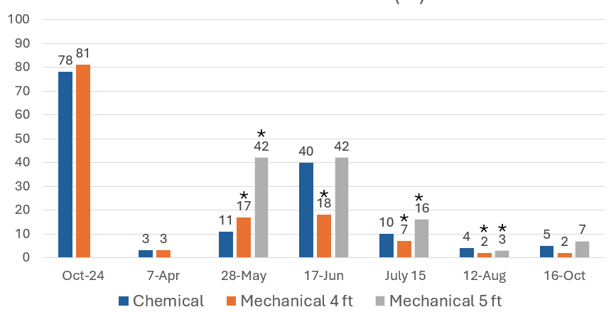

Block 2 (Woodchuck Hill SweeTango) % Herbicide Strip Weed Cover. Bars with a * indicate significant difference from the grower standard at p-value < 0.05.

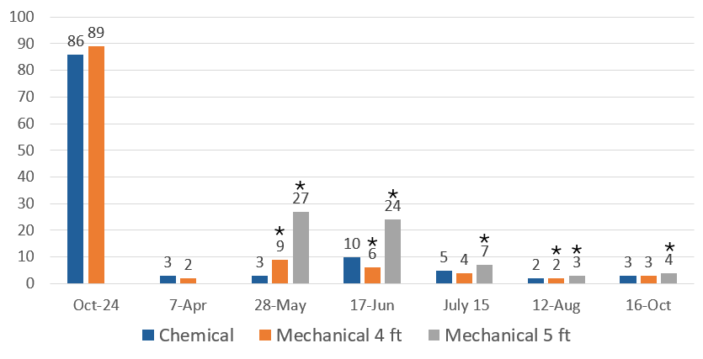

Results from our initial year suggest mechanical weeding with the Rinieri SRL once in May does not provide the same level of weed control as a single application of Gramoxone. We found the Rinieri SRL provided immediate disruption of the weed ground cover and removed the weed residue from the herbicide strip. The Gramoxone application took about a week to fully desiccate the weed cover, but regrowth was subsequently slower than the Rinieri treatment. The Rinieri did not control as wide of a swath of ground as the herbicide boom was able to cover, and could not reach completely up against the trees, as irrigation lines could have been tangled into the unit.

While one application alone may not be enough, we tentatively think using the unit in May and June may suppress spring weed pressure enough to replace a spring Gramoxone application until a systemic material can be applied later in the spring, when the systemics would be more efficacious against perennial weeds. For both treatments, perennial weeds (vetch, toadflax, and dock) grew back from their root systems following the initial applications, and long-term control in both plots was generally achieved only once systemic herbicide materials (glyphosate and 2,4-D) were applied. Once we got into July, we also began a drought at our field site. The lack of rain, in addition to the use of these systemic materials, may have also held back the regrowth of weeds throughout the summer.

The orchard we worked with produces apples on about 800 acres. If they were to replace one application of Gramoxone with this unit across the orchard, this would remove 220 gallons of Gramoxone from their program annually. This would save them approximately $11,000 on their herbicide bill. Further work is necessary to determine if we could remove additional post-emergent herbicide inputs using this unit.

Outreach: Initial results were shared at a weed management meeting held at the Hudson Valley trial site in Poughkeepsie on June 25, including presentations by Greg Peck, Mike Basedow, Max Pritchard (the hosting orchard manager), and Anna Wallis. Results were also shared at the Champlain Valley Summer Field Afternoon, held at Chazy Orchards on July 17.

Next Steps: Final data analysis is needed prior to submitting our final grant report. We plan to run this trial another year if funded, so that we can further reduce our herbicide inputs in the experimental treatment, and to assess potential short-term changes to soil health properties. We plan to hold additional meetings to discuss our findings, discuss the project at winter meetings, and will be writing up a Fruit Quarterly article on our findings at the conclusion of the project.

Objective 2: Evaluate the efficacy of a mulch and reduced herbicide program compared to a grower’s standard herbicide program.

Task 2.1: Establish an on-farm research trial with a commercial orchard in the Hudson Valley. The trial will consist of two treatments. 1) The growers standard seasonal weed management program of their choosing and 2) An adjusted weed management program where the herbicide strip is treated with a pre-emergent herbicide, covered in mulch, and treated with an organic contact herbicide as needed from May-August (when weeds reach 30% cover or 6 inches in height, whichever comes first).

Progress: In 2025, we conducted a trial at Titusville Farm in the Hudson Valley comparing a stacked hardwood mulch and capric + caprylic acid herbicide program to a conventional herbicide program. Both weed management programs were considered reduced input, omitting glyphosate and Gramoxone. Treatments were replicated on 5 individual rows in the orchard. Treatments and data collection went as planned in the proposal, with two exceptions:
- We decided not to collect height data in the project, as there were multiple weed species of various height, which would not correlate very well with overall weed control within the research plots.
- Post-emergent herbicide applications were intended to be applied when weeds were 6” tall or less. Due to extremely wet conditions and equipment challenges, two of the early season applications were slightly later than ideal.

Results of Objective 2 are as follows:

2025 Weed Pressure for conventionally managed vs. mulch + organic herbicide
in Poughkeepsie, NY demonstration. Dates with a * indicate significant difference from the grower standard at p-value < 0.05.
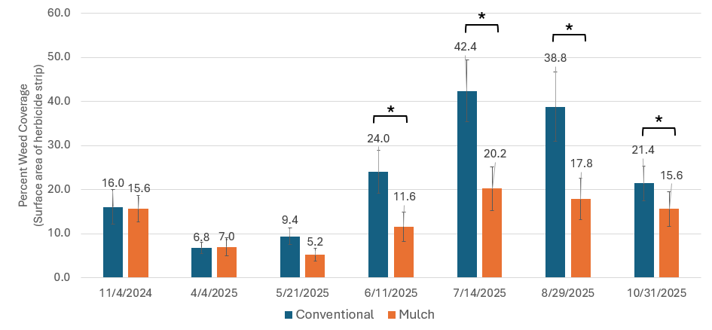
Preliminary results indicate weed pressure (percent ground cover) was comparable (May) or reduced (June through October) in the mulch treatment.

Outreach: Early results were shared at a weed management meeting held at the trial location in Poughkeepsie on June 25, including presentations by Greg Peck, Mike Basedow, Max Pritchard (the hosting orchard manager), and Anna Wallis.

Next Steps: Final data analysis is needed prior to submitting our final grant report. We plan to run this trial another year if funded, so that we can fine tune our herbicide inputs in both treatments, and to also assess potential short-term changes to soil health properties. We plan to hold additional meetings to discuss our findings, discuss the project at winter meetings, and will be writing up a Fruit Quarterly article on our findings at the conclusion of the project.

Objective 3: Evaluate changes in short-term (1 year) soil health within the herbicide strips from the implementation of the weed-management strategies within objectives 1 and 2.

Task 3.1: We will collect Cornell soil health samples from each on-farm research soil treatment in May 2025 and 2026, prior to and following our weed management treatments, one test per treatment will be collected. The Cornell Soil Health test will provide key soil quality indicators, including: organic matter, surface and subsurface hardness, a respiration estimate, and aggregate stability.

Progress: Initial soil health samples were collected in April 2025, prior to treatments being applied to the field plots. Initial results were shared with participating growers, and gave us the opportunity to discuss the sites’ current high and low quality soil factors.

Initial soil health scores from the trial locations (prior to treatment applications) are as follows:

Chazy Castine – Chemical: 75 (High)
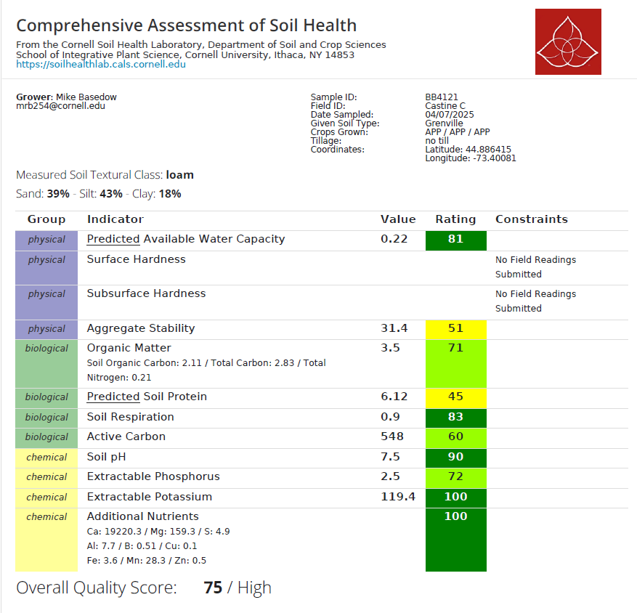

Chazy Castine – Mechanical: 72 (High)
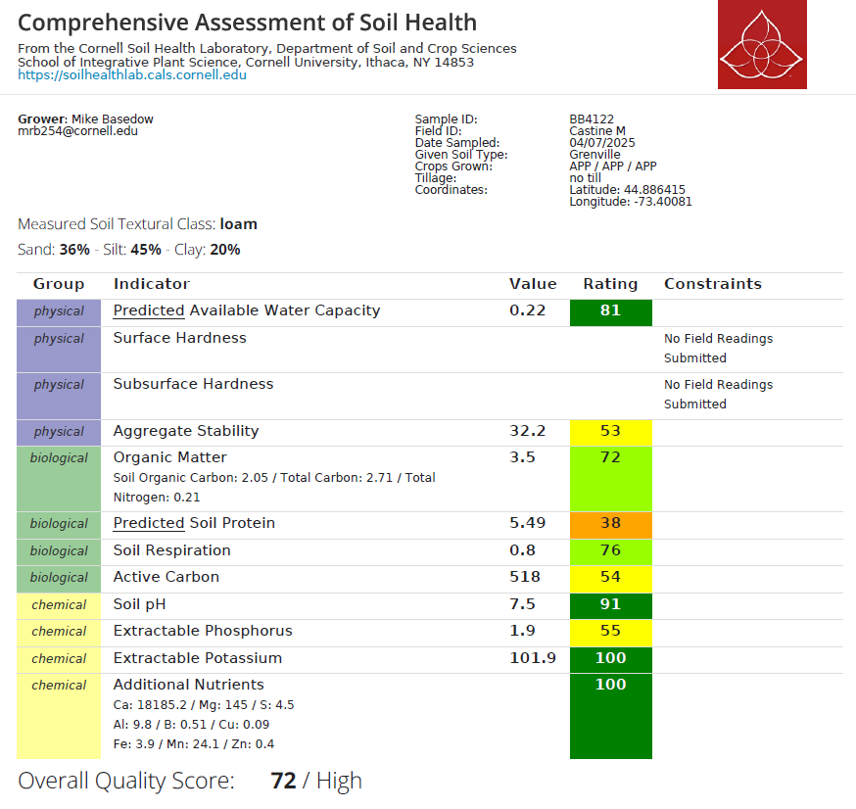

Chazy Woodchuck Hill – Chemical: 83 (Very High)
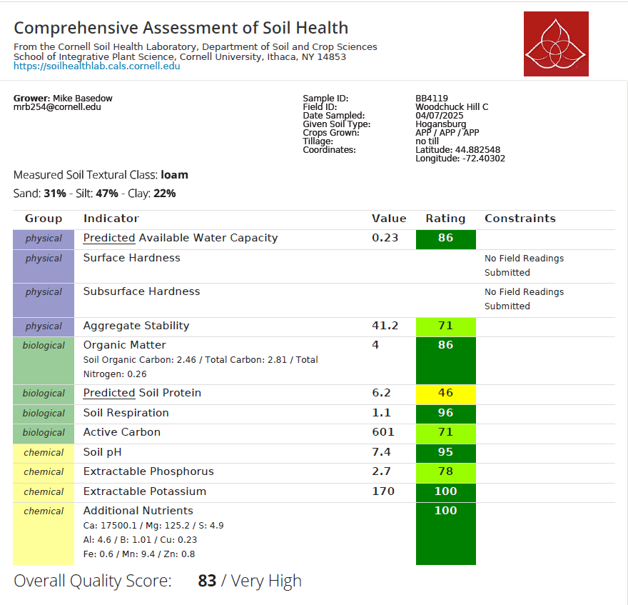

Chazy Woodchuck Hill – Mechanical: 79 (High)
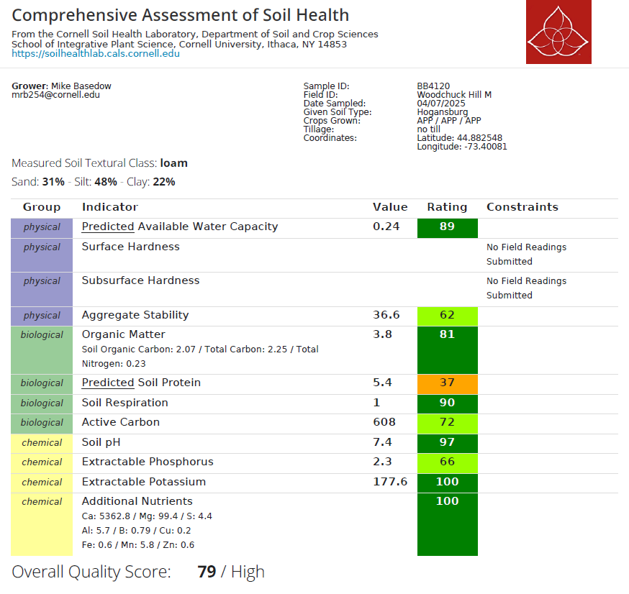

Titusville – Control: 71 (High)
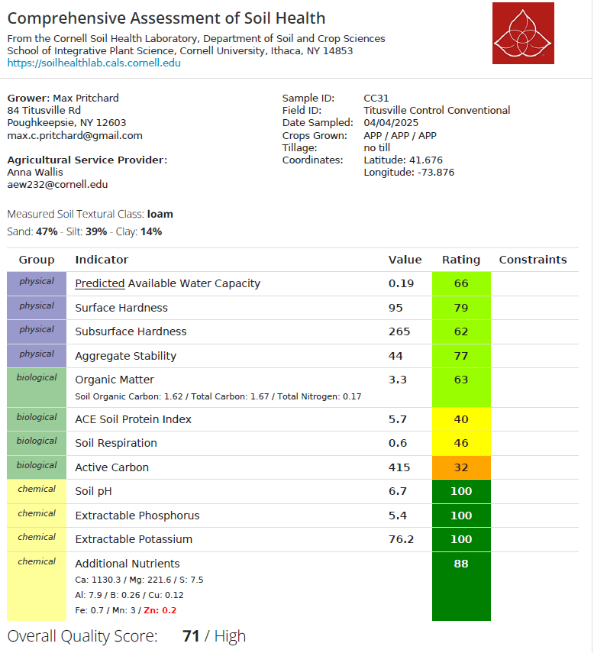

Titusville – Mulch: 65 (High)
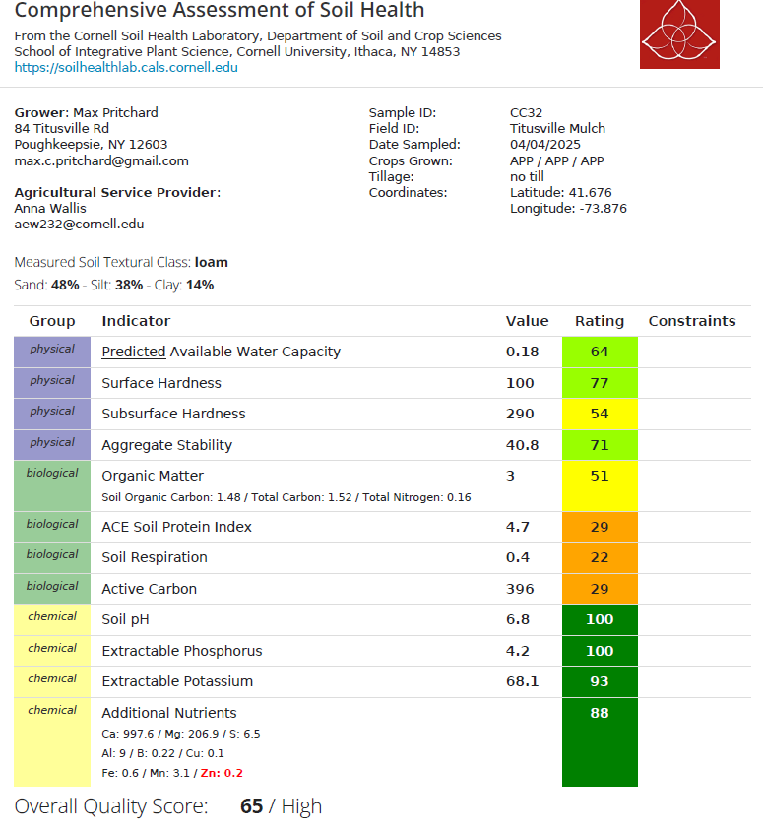

We did not collect surface or subsurface hardness results at the Champlain Valley field sites, as the soils across the two field sites were extremely hard and rocky, making it difficult to take these measurements.

Next Steps: In April 2026, we will collect the second set of samples to determine the first-year impacts on the various weed management strategies on the orchard soil quality. If funded for a second year, we will be collecting a third year of samples in spring 2027 to further assess the impacts of these weed management strategies on soil quality. These results will ultimately be shared at grower meetings and in a Fruit Quarterly article.

